**STW300CEM Android Applications Development**

**1st Assignment**

**Deadline: 22nd March**

Q1. Convert this UML class diagram to java code and test the java code.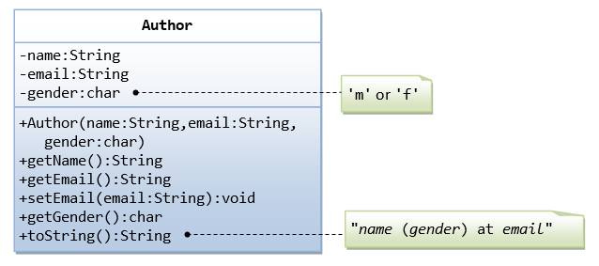

Q2. Convert this UML class diagram to java code and test the java code.

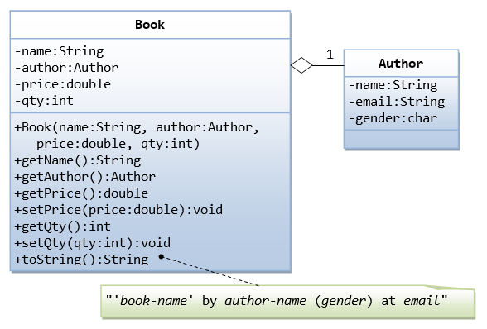

Q3. Using **inheritance** convert the following UML class diagram to java code and test the java code.

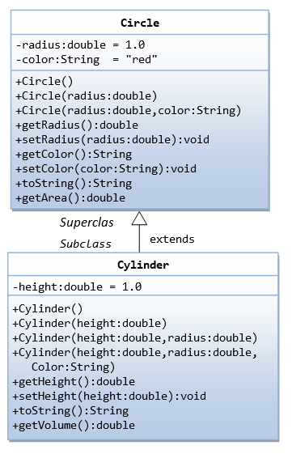

Q4. What is encapsulation and advantages of encapsulation? Explain with an example.

Q5. What is abstract method in java? Explain with an example.

Q6. What is an interface in java? Explain with an example.

Q7. Write a Java program to find the maximum and minimum value of an array.

Q8. Write a Java program to reverse an array of integer values.

Q9. Write a Java program to find the second largest element in an array

Q10. What is an ArrayList in java? Explain with an example.